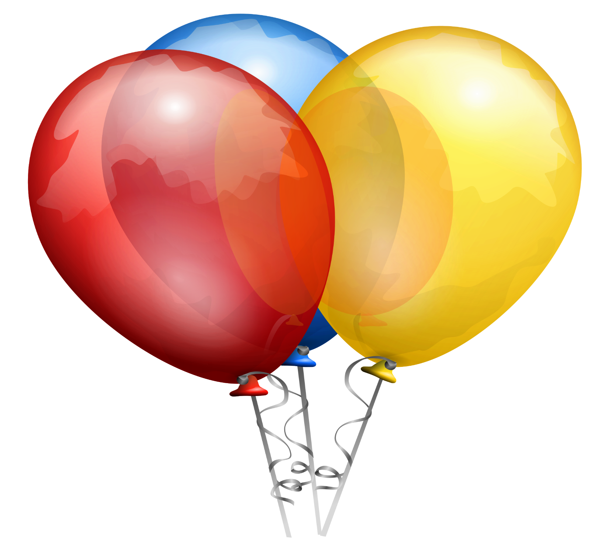
FUN FAIR
SATURDAY, JUNE 13, 2026
12:00-4:00 AT REBER PARK
THERE WILL BE GAMES, PRIZES, FOOD AND A RAFFLE FOR GIFT BASKETS

